Uva Wellassa University of Sri Lanka Faculty of Applied Sciences  Department of Computer Science and Informatics  Undergraduate Research Project (CST/IIT)- 2024/2025 |  |  |  | 
PROGRESS REPORT Report No: |  |  |  | 05
Name of the student/s: | W.K.Gayan
Registration Number/s: | UWU/IIT/21/062
Degree Programme/s: | Industrial Information Technology
Title of the Study: | AI-Based Tomato Ripening Stage Detection and Sorting System with Shelf-Life Estimation for the Commonly Consumed Padma Variety in Sri Lanka Using Computer Vision and Conveyor Automation
Institute/s where studies  are affiliated with: | Uva Wellassa University of Sri Lanka
Name of the Supervisor/s: | Ms. D.P. Jayathunga(Principle supervisor)  Dr. U.G.A.T. Premathilake (Co-Supervisor)  Ms. M.P.A.M. Rathnakumara (Co-Supervisor)
Period of Progress: | From:29/04/2026 |  | To:16/05/2026
Progress (A description by the student).

1) Accomplished activities
During this reporting period, the project moved from design validation to physical prototype development. The primary focus was on translating the finalized CAD design into a real-world hardware structure and ensuring that the foundational mechanical components were assembled according to the planned specifications.
The prototype’s base metal structure was successfully fabricated based on the finalized CAD design. A 1-inch metal box bar was used to construct the frame to ensure structural stability and durability for the conveyor system. The fabricated structure was carefully aligned with the original CAD measurements to maintain dimensional accuracy.
Additionally, the camera mounting unit was designed, fabricated, and installed onto the prototype structure. This setup was developed to ensure proper camera positioning for accurate image capture during tomato ripeness detection. The installation process also considered stability and field-of-view alignment for future testing phases.

Milestones achieved
- Prototype Base Fabrication: Constructed the physical base frame according to the finalized CAD design specifications.
- Material Implementation: Utilized 1-inch metal box bars for durable structural support.
- Camera Mount Development: Designed and fabricated the camera mounting mechanism.
- Camera Installation: Successfully installed the camera mounting unit onto the prototype frame.
- Structural Verification: Verified that the fabricated prototype dimensions align with the original CAD plan.
Project Evidence / Images

Figure 1: CAD design plan of the prototype structure
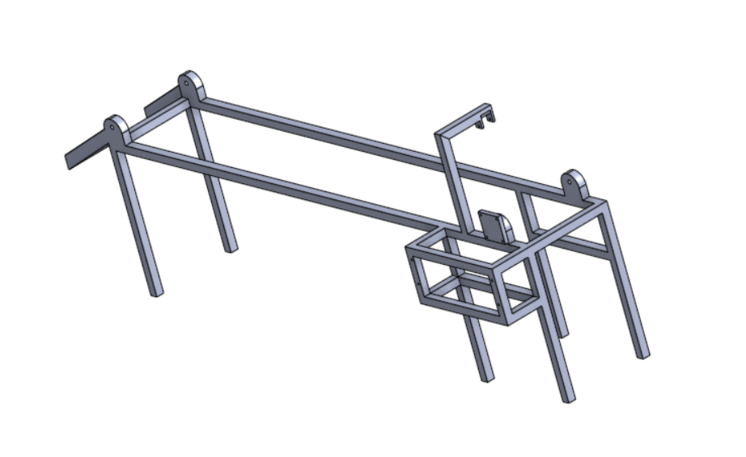
Figure 2: Completed prototype base metal structure
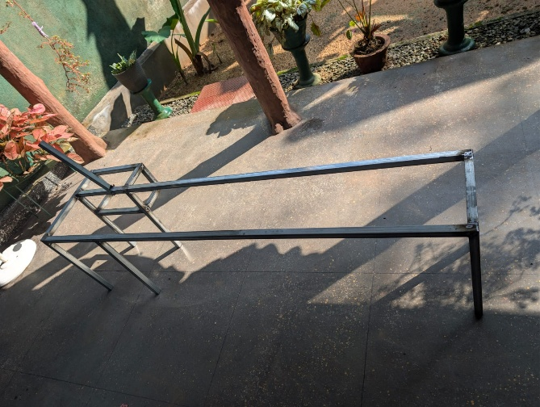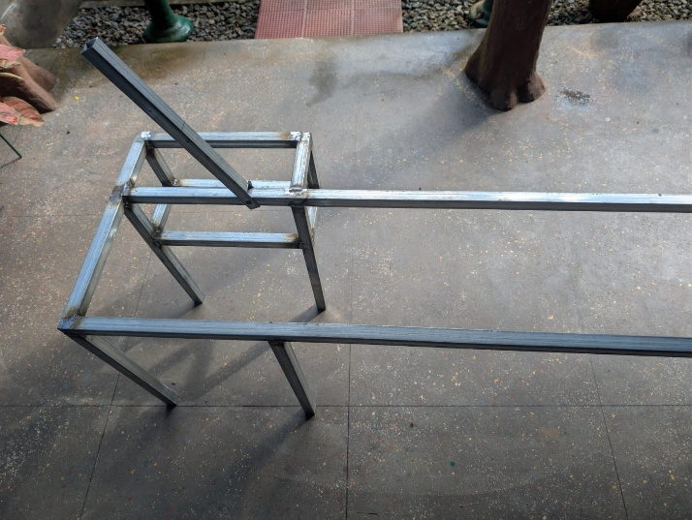

2) Activities planned for the Next Period
The upcoming phase will focus on integrating functional components into the fabricated structure and preparing the prototype for operational testing.
Planned Activities
- Install the conveyor motor and belt mechanism.
- Integrate sensors required for tomato detection and sorting.
- Begin testing camera image capture quality under real operating conditions.
- Connect the hardware components with the Python-based detection system.
- Perform initial testing of the automated sorting mechanism.

Signature of the Student: |  | 
Approval Signature of Supervisor:
Approval Signature of Co-Supervisor (If any):
Date: |  | 16/05/2026

